**Key Findings on Inverse Relationship Between Bitcoin and Altcoins by Rolling 30-day correlation.**

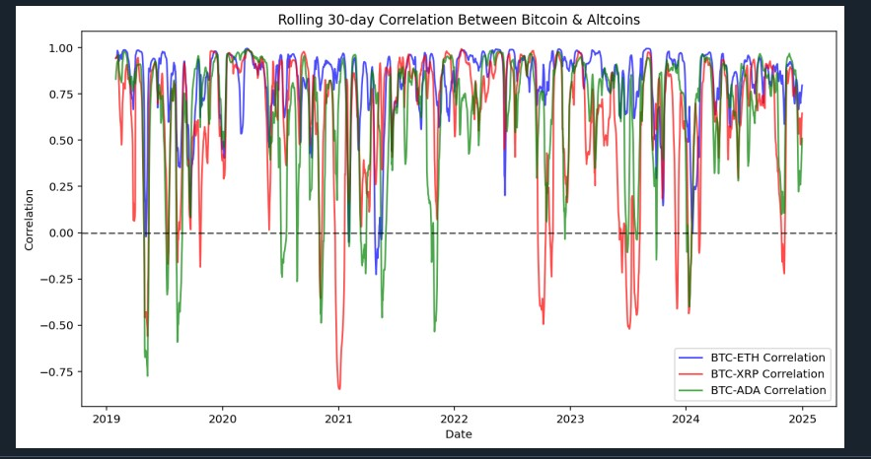

* **Mostly Positive Correlation**

1. Overall: The chart shows that BTC-ETH, BTC-XRP, and BTC-ADA usually have correlations above 0, often 0.5 or higher.
2. Implication: When Bitcoin’s price rises, altcoins typically rise too (and vice versa). This is common in crypto because of shared market sentiment and overlapping investor bases.

* **Periods of Inverse Correlation:**

Based on the data, some notable periods where Bitcoin and altcoins moved in opposite directions (negative correlation):

* Early 2019
* Early 2020
* Mid-2021
* Mid-2022
* Late 2023

These could be linked to market cycles, investor behaviour shifts, or Bitcoin dominance variations.

* **Possible Explanations for Inverse Movements:**

1. Infrequent but Significant: There are clear points where the lines dip below the 0 mark. That indicates a negative correlation (inverse relationship) for that 30-day window.
2. Examples from the Chart:

* Around late 2019 and early 2020, you see some negative spikes.
* Occasional dips near mid-2021 and again around 2022–2023.

When the correlation dips below zero:

* Bitcoin might be going up while the altcoins drop (or remain stagnant).
* Or Bitcoin might be falling while altcoins outperform (i.e., remain stable or rise).

**Why Do These Inverse Relationships Happen?**

1. **Altcoin-Specific News or Upgrades**

* Ethereum’s “The Merge” (2022): Big event that sometimes-made ETH’s price deviate from BTC.
* XRP’s SEC Lawsuit: Regulatory uncertainty drove independent price swings.
* Cardano’s Alonzo Hard Fork: Generated unique excitement (or worry) that temporarily decoupled ADA from BTC.

1. **“Alt Season” vs. “Bitcoin Dominance” Shifts**

* Rotation to Altcoins: Investors seeking higher returns might leave BTC, boosting altcoins even if Bitcoin is flat or dropping.
* Bitcoin Dominance: When BTC’s share of the total market cap falls, altcoins often surge, creating inverse correlation.

1. **Regulatory & Macro Events**

* Regulations: Specific tokens may be targeted, causing altcoins to diverge from BTC.
* Macro Factors (e.g., Fed Rate Hikes): Usually move all cryptos together, leading to generally positive correlation, but can still create short-term anomalies.

1. **Market Liquidity & Trader Psychology**

* Bitcoin as “Safer” Crypto: During uncertainty, traders sell altcoins and hold BTC, producing brief negative correlation.
* Seeking Bigger Gains: If BTC gets “boring,” capital flows to altcoins, potentially pushing their prices up while BTC remains stable.